**Result Demonstration Report  
Haskell County Forage Trial**

**Texas A&M AgriLife Extension Service**

**Haskell County**

**Cooperator: Kenneth Baker, Kenneth Baker Farms**

**Jason Westbrook, Haskell County Extension Agent**

**Jerry Coplen, Knox County Extension Agent**

**Dr. Emi Kimura, Texas A&M Agrilife Extension Agronomist**

**Jonathon Ramirez, Texas A&M Agrilife Extension Research Associate**

***Summary***

*A 31 variety forage trial was demonstrated and a forage field day was held on April 4th in Haskell County. Plots of each forage variety were replicated and 12” strips were clipped from each plot with green and dry weights measured. The objective was met to determine lbs. per acre of each variety in relation to cattle grazing. Plots were planted October 2, 2015. Heavy rains washed the original plots out and plots were replanted November 12, 2015. Three clippings had originally been planned to report weights but due to late plantings only two were taken.*

***Objective***

*Haskell County continues to be one of the largest producers in the state for forage acreage designed for winter grazing. According to the 2015 Texas Agrilife Extension Ag Increment Report revenue from cattle in Haskell County are estimated at $18,000,000. The objective of this demonstration is to determine forage varieties and yields per acre of each. Producers from Haskell and Knox Counties came together for a brief meeting to discuss various varieties of forage and what could be done to determine the yields.31 varieties of forage were picked. The forage trial was made up of various varieties of wheat, rye, triticale, oats and barley.*

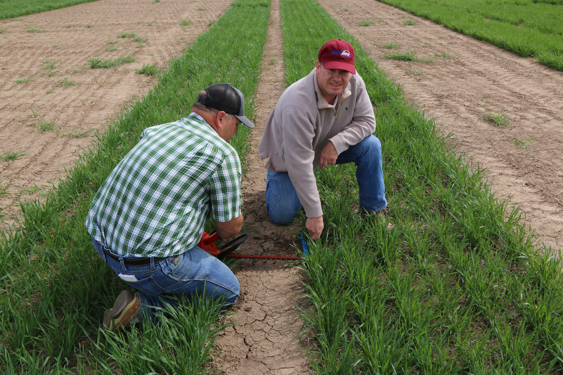

***Materials and Methods***

*Soils samples taken from acreage on Kenneth Baker Farms located right off of Hwy 222 in*

*Haskell County indicated 3 gallons of 10-34-0 and 40 lbs of nitrogen were needed to meet proper fertility needs. A seven row planter was used with a seeding rate of 55 lbs. to the acre for planting two separate plots of each variety. Plots were planted on October 2, 2015. Heavy rains forced a replant because seed had washed out. Plots were replanted on November 12, 2015.*

*The first clipping was taken after 112 days of growth on March 4, 2016. Each plot had one 12” strip removed from the ground up to include all growth. Forage was collected and placed in a bag to be weighed and green weight was recorded. The forage was then placed in ovens to dry and remove moisture content which gave us the final dry weight of forage. The same day the first clipping was taken the plots were mowed at 4” uniformly to simulate grazing. The second clipping was taken 30 days later on April 5, 2016. The clippings from each plot were taken at 4” from the base of the plant to account for the previous mowing of plots. Again 12” strip samples were taken and green and dry weights were recorded.*

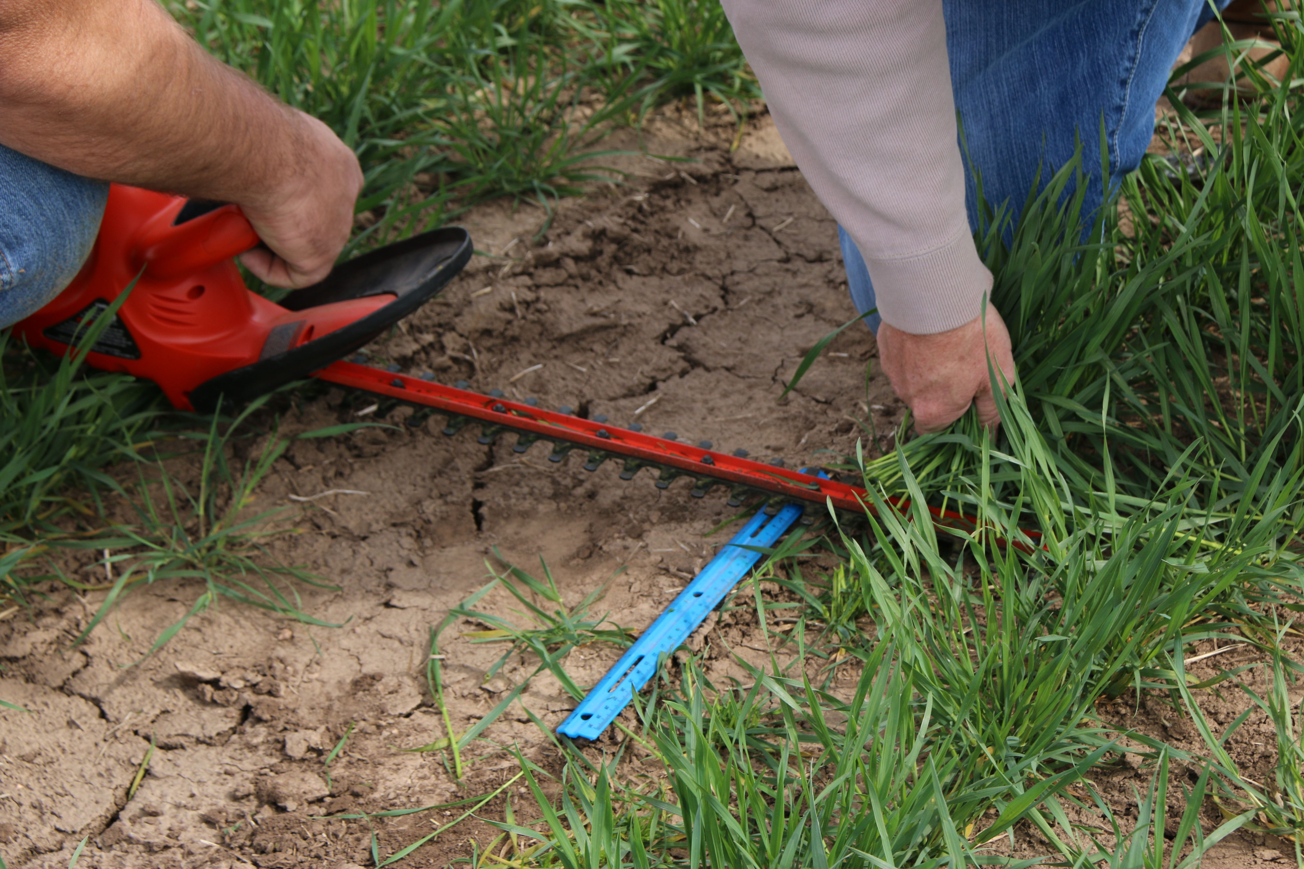

***Results and Discussion***

*Triticale, rye, oats, barley and wheat are represented in the forage trials. A field day was held on April 4,, 2016 with Clark Neely as guest speaker. Many of the wheat varieties had some degree of rust damage. Clark discussed striped rust and control methods for each wheat variety. Plots were marked with signs for visual representation. The results of the forage trial are listed below.*

*Each forage variety list the total weight of forage that was produced from each clipping and ranked by the total weights per acre from both clippings. Rust rankings for each wheat variety are also listed below as to the severity they were infected.* *Maton Rye produced the most forage of all the forages with TAM 606 Oats taking second. The wheat variety of Gallagher produced the most forage compared to other wheat varieties. Triticale 348 was the top triticale and Tambar 501 was out produced by Maton Rye by 900 lbs.*





**Conclusions**

*The objectives of the project were met to determine lbs. per acre of each forage variety. The weights of forage produced met the project outcome. The results will all be mailed to our local Haskell County producers for options on forage selection next year. We will continue the forage plots next year with new varieties as well as look at dual purpose varieties for forage and seed.*

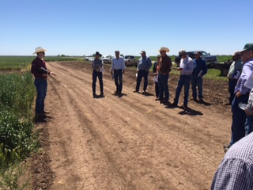

**Acknowledgements**

*I would like to thank Mr. Kenneth Baker and Mike Urbanczyk for the use of the land, signage and plot labels. We would also like to thank Dr. Emi Kimura for data analyses and Jonathon Ramirez for dry weights and measures. A thank you also goes to Dr. Clark Neely for taking the time to contribute to the forage field day as well as local producers and seed companies within the area that donated seed.*